
Faculty of Applied Sciences
Bachelor of Science in Computing

COMP490 Final Year Project
Project Proposal
Academic Year 2022/23

Text Detection and Recognition in Image-Based on Deep Learning
Project number: | 30
Student ID: | P1908370
Student Name: | Eden Xiang
Supervisor: | Jacky Tang
Assessor: | Charles Lam
Submission Date: | 08/09/22

Table of Contents
1 Project Description 2
1.1.1 Background 2
1.1.2 Difficulties 3
1.1.3 Main objective 3
2 Summary of Related Work and Key References 4
3 Project Work Plan 5
3.1.1 Dataset preparation 6
3.1.2 Detector design 6
3.1.3 Train and improve detector 6
3.1.4 Recognizer design 6
3.1.5 Train and improve Recognizer 6
3.1.6 Integrate recognizer and detector 7
3.1.7 Model Deployment 7
3.1.8 Testing and debugging 7
4 Risk Assessment 7
4.1.1 Ethics 7
4.1.2 Hardware 7
5 References 10

Project Description

Background
It has now become popular in mainland China to have students answer questions on a special type of answer card, which generally uses positioning points to locate answers and scan them into the computer by dividing them according to the pre-set position. This allows the teacher to read the paper from anywhere, anytime, via computer or cell phone. Using this method can effectively reduce the teacher's marking burden and speed up the marking efficiency. In addition, machine marking can be more objective in judging the scores of subjective questions, and can also avoid the original test papers being tampered with, and the confidentiality of the test papers is stronger, which can better protect the interests of the candidates.
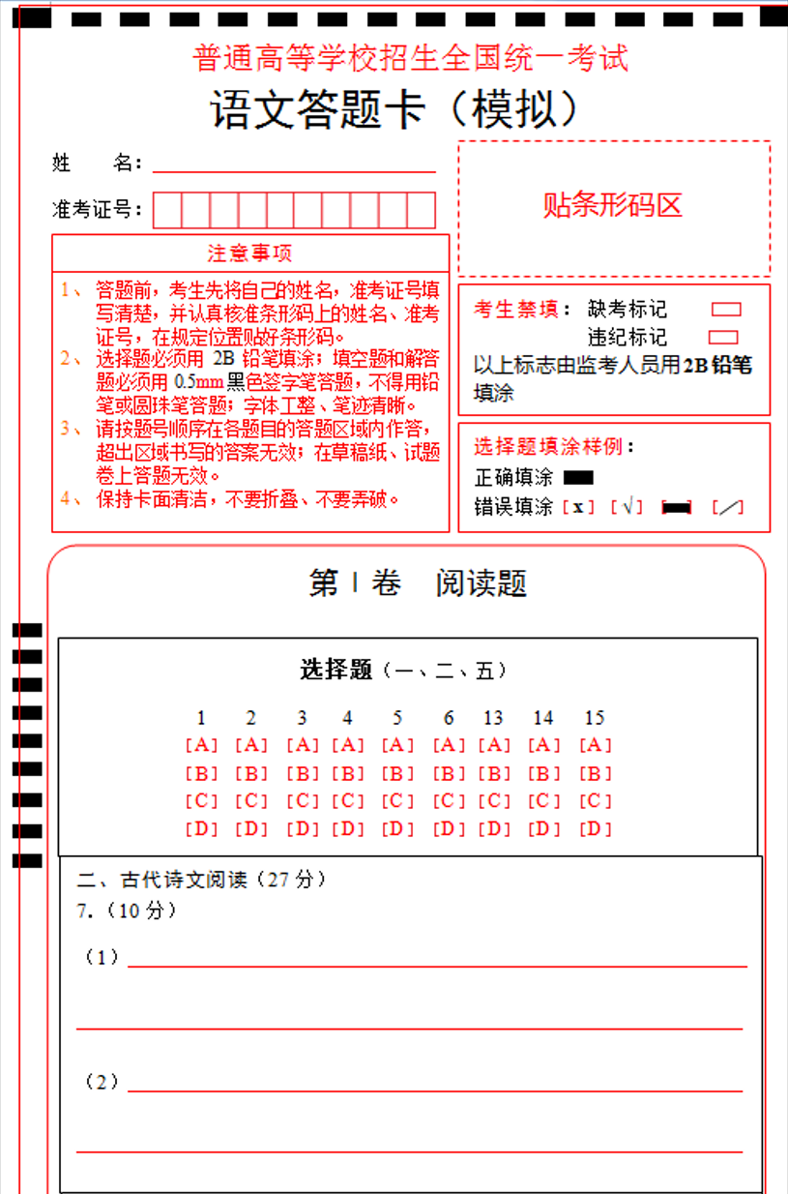
Figure 1: Answer sheet for machine recognition
However, this approach is still not good enough. One problem is that it requires an answer card designed specifically for the test and may require a special optical recognition machine. Another problem is that the existing marking system can only judge multiple choice questions [1], not fill-in-the-blank questions that have standard answers.
This project intends to build an intelligent marking system that recognizes students' handwritten answers and grades them against standard answers. The text detection and recognition part will be implemented using image processing and deep learning techniques. The dataset used for training will use the publicly dataset ICDAR.

Difficulties
The main difficulty of this project is to ensure the accuracy of the model recognition. Although reading text is not a new topic in computer vision area, most of the research work has been devoted to the recognition of English characters, and those tasks only consist of 26 classes of letters, very little work has been done on other language characters [2] [3]. Moreover, if we directly apply the techniques in English character recognition to Chinese characters recognition, we will face the trouble of class-imbalance.

Main objective
This project planning to use deep learning technology to train neural network to perform Chinese character detection and recognition task. Figure 2 shows the workflow of this model.
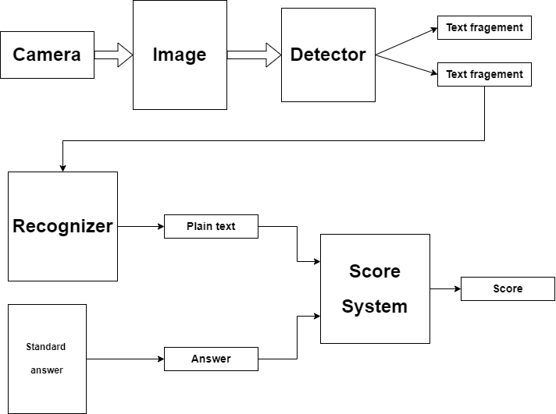
Figure 2: Model workflow
The objectives of this project are:
- The model can read and process paper images form camera.
- The model can detect the text in the image and do the segmentation by the question.
- The model can recognize the text in question answer and output the plain text.
- The program can compare the answer with the standard answers.

Summary of Related Work and Key References
In this section, I will introduce the technologies used in this project in order to give the reader a better understanding of the project:
This project mainly uses text reading technology, which mainly includes two parts: text detection and recognition.
Text detection in realistic life scenarios is a complex task and there are several approaches to achieve it. One approach is based on sliding window [4] However, this method is less efficient and the detection of different scaling and rotation is not ideal.
Another well-known approach is region-based approach [5] Despite being faster than sliding-window methods, the region-based approach needs additional step to do the region detection, therefore the false detections require additional classification step.
This project will use Connectionist Text Proposal Network (CTPN) [6] which is based on VGG [7] and BLSTM [8] model.
Figure 3: Architecture of the CTPN and the sequential fixed-width fine-scale text proposals outputs
For the recognition, Convolutional deep neural network (CDNN) shows very good results on classification tasks, therefore many models developed since then are basically based on CDNN. like image classification [9].
There are also attempts to deconstruct text for recognition [3]. This approach is a good solution to the problem of exhaust softmax layers in representational capability due to the large character set that needs to be recognized, such as Chinese characters (more than 7,000 commonly used characters).
This project will use convolutional recurrent neural network (CRNN) [10] to do the recognition work. Considering that Chinese characters are based on pictographs, recurrent neural networks can better extract the relationship between parts and parts.

Project Work Plan
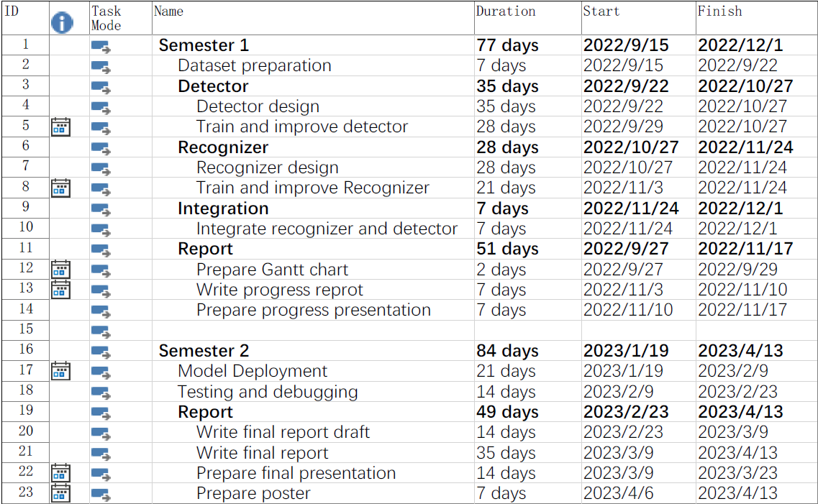

Dataset preparation
Duration: Week 4 (9.15 – 9.22)
Description: Collect Chinese handwriting dataset.

Detector design
Duration: Week 5 – Week 9 (9.22 – 10.27)
Description: Choose and design proper deep learning model to complete the text detection task.

Train and improve detector
Duration: Week 6 – Week 9 (9.29 – 10.27)
Description: Train the model and adjust the model parameters based on the results.

Recognizer design
Duration: Week 10 – Week 13 (10.27 – 11.24)
Description: Choose and design proper deep learning model to complete the text detection task.

Train and improve Recognizer
Duration: Week 11 – Week 13 (11.3 – 11.24)
Description: Train the model and adjust the model parameters based on the results.

Integrate recognizer and detector
Duration: Week 13, 14 (11.24 – 12.1)
Description: Integrate recognizer and detector model.

Model Deployment
Duration: Week 1 – Week 3 (1.19 – 2.9)
Description: Deploy those models on the program.

Testing and debugging
Duration: Week 4 – Week 5 (2.9 – 2.23)
Description: Test the program and fix bugs.

Risk Assessment

Ethics
Most of the training data can be found on the internet, but this project may still need human participants and collect their handwriting. Some ethical problems may be involved in this project. For participants, I will avoid collecting data from vulnerable groups and protect the rights of participants. For data collected, all data stored should be anonymized and should not contain sensitive data about living individuals.

Hardware
In theory, the deep learning’s computational requirement is hard to estimate [11], but there are important reasons to believe that the computational requirement is related to model complexity. My hardware may not meet this requirement. A substitute solution is rent a high compute capability server and train model on it.

Priority | Risk Identifier and Description
1 | Risk 1: Ethics
2 | Risk 2: Hardware
Table 1: Table of prioritized risk

Probability | High
Probability | Medium |  | Risk 2
Probability | Low |  | Risk 1
Probability |  | Low | Medium | High
Table 2: Probability impact matrix

References

[1] | J. A. Catalan, “A Framework for Automated Multiple-Choice Exam Scoring with Digital Image and Assorted Processing using Readily Available Software,” LSU Research Congress, 2017.
[2] | R. K. R. I. K. Neha Sahu, “Survey and Analysis of Devnagari Character,” International Journal of Computer Applications (0975 – 888), June 2012.
[3] | G. Kim, J. Son, K. Lee and J. Min, “Character decomposition to resolve class imbalance problem in Hangul OCR”.
[4] | K. Wang, B. Babenko and S. Belongie, “End-to-end scene text recognition,” International Conference on Computer Vision (ICCV), November 2011.
[5] | C. Yao, X. Bai, W. Liu, Y. Ma and Z. Tu, “Detecting texts of arbitrary orientations in natural images,” IEEE Conference on Computer Vision and Pattern Recognition, June 2012.
[6] | Z. Tian, W. Huang, T. He, P. He and Y. Qiao, “Detecting Text in Natural Image with Connectionist Text Proposal Network,” Computer Vision – ECCV, 2016.
[7] | A. Z. Karen Simonyan, “Very Deep Convolutional Networks for Large-Scale Image Recognition,” arXiv:1409.1556, 2014.
[8] | Z. Tian, W. Huang, T. He, P. He and Y. Qiao, “Framewise phoneme classification with bidirectional LSTM and other neural network architectures,” ECCV Computer Vision , 2016.
[9] | D. Ciregan, U. Meier and J. Schmidhuber, “Multi-column deep neural networks for image classification,” IEEE Conference on Computer Vision and Pattern Recognition,, 2012.
[10] | X. Fu, E. Ch’ng, U. Aickelin and S. See, “CRNN: A Joint Neural Network for Redundancy Detection,” IEEE International Conference on Smart Computing, 2017.
[11] | K. G. K. L. G. F. M. Neil C. Thompson, The Computational Limits of Deep Learning, 2022.
[12] | “Optical character recognition - Wikipedia,” 30 08 2022. [Online]. Available: https://en.wikipedia.org/wiki/Optical_character_recognition.
[13] | L. N. J. M. Michal Busta, “FASText: Efficient Unconstrained Scene Text Detector,” IEEE International Conference on Computer Vision (ICCV), 2015.
[14] | A. V. A. Z. Ankush Gupta, “Synthetic Data for Text Localisation in Natural Images,” IEEE Conference on Computer Vision and Pattern Recognition (CVPR), 2016.
[15] | R. Smith, “An Overview of the Tesseract OCR Engine,” Ninth International Conference on Document Analysis and Recognition (ICDAR 2007), September 2007.

